

MassMutual DI Underwriting changes enable faster, simpler business processes

  
  Jason Paine
  Head of Disability New Business & Underwriting

Faster. Simpler. Built to help you win.
We heard you—and we took action. MassMutual Disability Income (DI) Underwriting is eliminating telephone-based client medical interviews (Tele-CMI) and moving to a fully digital Client Medical Interview (CMI) for all DI products, ages, and amounts.

This is more than a process change—it will help you place business faster and improve your client's experience with MassMutual.

Benefits of eliminating Tele-CMI:

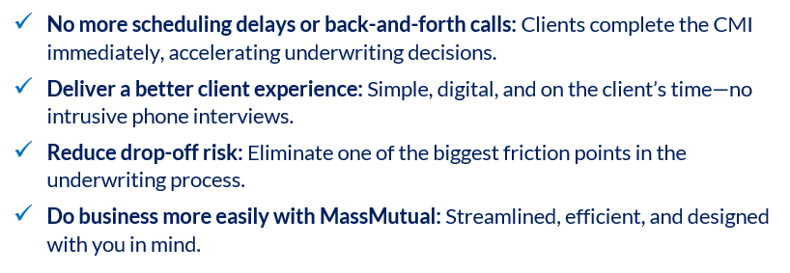

Note: For any cases currently in underwriting, please email your underwriter to request a switch from Tele-CMI to CMI if desired.

DI Medical manual modernization
Another major DI underwriting enhancement is underway! MassMutual has begun an initiative to modernize our medical underwriting guide. The result will be a more advanced, consistent, and competitive approach to evaluating risk.

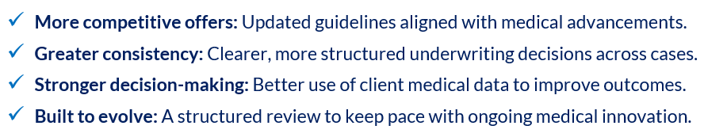

This is more than an update—it's a step change in how MassMutual approaches DI underwriting. Modernizing our medical guide helps position you to win more cases, deliver better outcomes for your clients and confidently place business knowing decisions reflect today's medical landscape.

Marketing resources
Visit the MMSD DI Marketing Hub for producer and client guides, infographics, sales concepts and more.



We’re investing in tools and capabilities that help you grow—and this is a key part of that commitment. More details will be shared soon.

Further info:
- Contact your MMSD DI Underwriter.

